**VISSIM Model Data Collection and Calibration Results**

I-66 Westbound Outside Beltway

1. Calibration Overview

* I-66 Westbound between interchange I495 (MM64) and US-29 (MM 51), six interchanges on this 13 miles long section
* Data collection period: Nov. 13 Wednesday, 15:00- 18:30
* Data
  + Speed and volume data collected by six RTMS trailers, along major mainline segments
  + On- and off-ramp volume data collected by GoPro cameras
* Calibration Approach
  + Initial calibration was performed to narrow down parameter set candidates by using Lantin Hypercube Sampling Design(LHD) approach
  + A total of 500 scenarios created by LHD were evaluated by VISSIM with 5 replications for each scenario to choose the best candidate scenario.
  + The selected candidate was fine-tuned to obtain the final simulation model

**Table 1 WB RTMS Trailer Location**

|  |  |  |  |  |  |
| --- | --- | --- | --- | --- | --- |
| Interchange ID | Nearest Exit | Nearest Crossing St | Mile Marker | Lat | Long |
| IC 1 | 62 | Rt 243/Nutley St | 61.6 | 38.879646 | -77.250504 |
| IC 2 | 60 | Rt 123 | 60.0 | 38.8705306 | -77.3009333 |
| IC 3 | 57 | Rt 50 | 58.0 | 38.861246 | -77.352807 |
| IC 4 | 55 | Rt 286 | 55.5 | 38.856415 | -77.378025 |
| IC 5 | 53 | Rt 28/Sully Rd | 53.0 | 38.847060 | -77.429654 |
| IC 6 | 52 | Rt 29 | 51.8 | 38.8386833 | -77.4462111 |

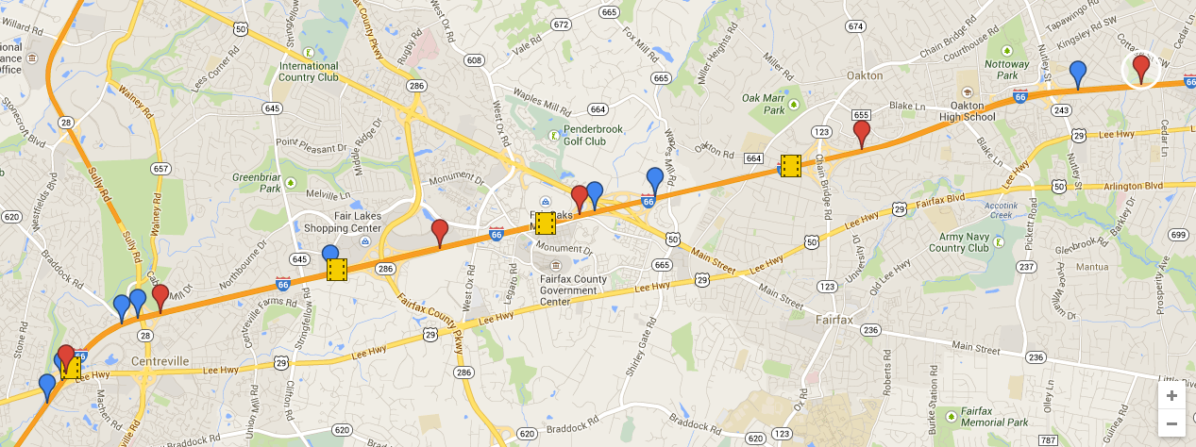

Interchange 6

Interchange 5

Interchange 4

Interchange 3

Interchange 2

Interchange 1

**Figure 1 WB Trailer Locations Map**

* Segment travel time data collected by Inrix

**Table 2 WB Inrix TMC Locations**

|  |  |  |  |  |  |  |  |
| --- | --- | --- | --- | --- | --- | --- | --- |
| TMC Code | From (Lat,Lon) | | | To (Lat,Lon) | | | Mileage |
| 110+04176 | I-495/EXIT 64 | 38.88308 | -77.2295 | VA-243/NUTLEY ST/EXIT 62 | 38.87883 | -77.2628 | 1.8 |
| 110P04176 | I-495/EXIT 64 | 38.87883 | -77.2628 | VA-243/NUTLEY ST/EXIT 62 | 38.87824 | -77.2703 | 0.4 |
| 110+04177 | VADEN DR/  EXIT 62 | 38.87824 | -77.2703 | VA-123/EXIT 60 | 38.87741 | -77.2748 | 0.3 |
| 110+04178 | VA-243/NUTLEY ST/EXIT 62 | 38.87741 | -77.2748 | VA-123/EXIT 60 | 38.8704 | -77.3006 | 1.4 |
| 110P04178 | VA-123/EXIT 60 | 38.87041 | -77.30064 | US-50/EXIT 57 | 38.8676 | -77.3162 | 0.9 |

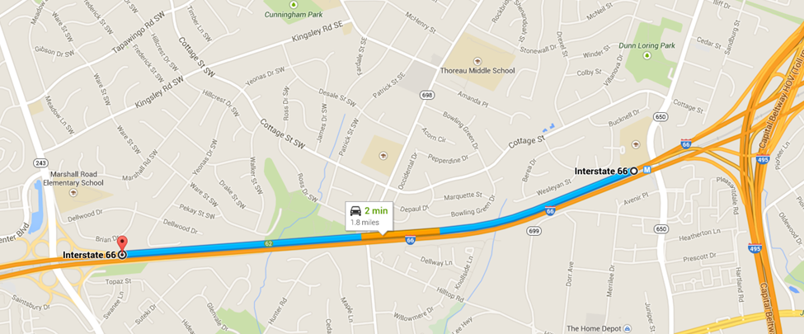

**Figure 2** TMC110+04176

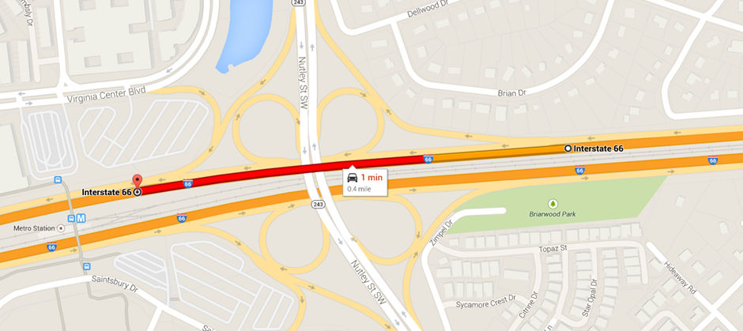

**Figure 3** TMC110P04176

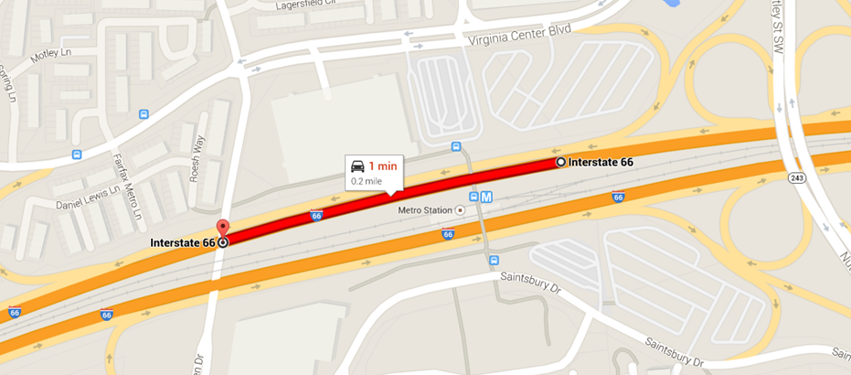

**Figure 4** TMC110P04177

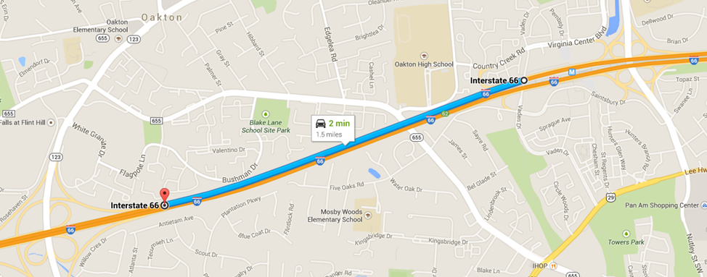

**Figure 5** TMC 110+04178

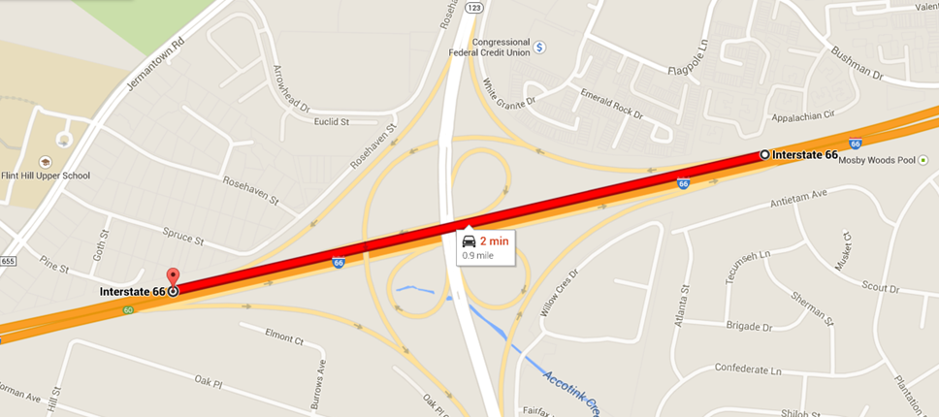

**Figure 6** TMC 11P04178

1. **Calibration Results : Traffic Count**

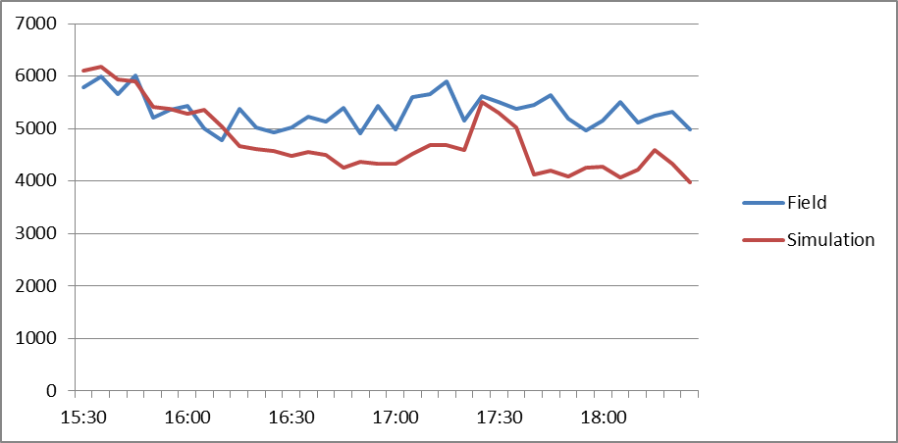

Interchange #1

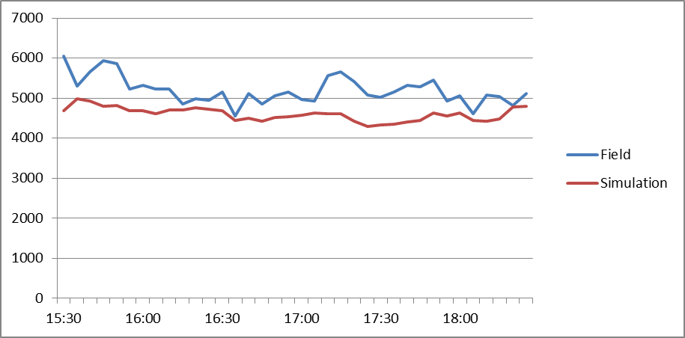

Interchange #2

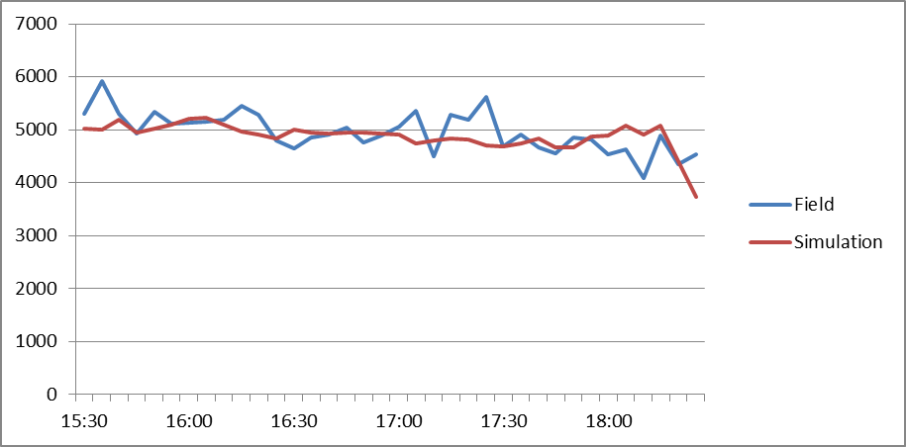

Interchange #3

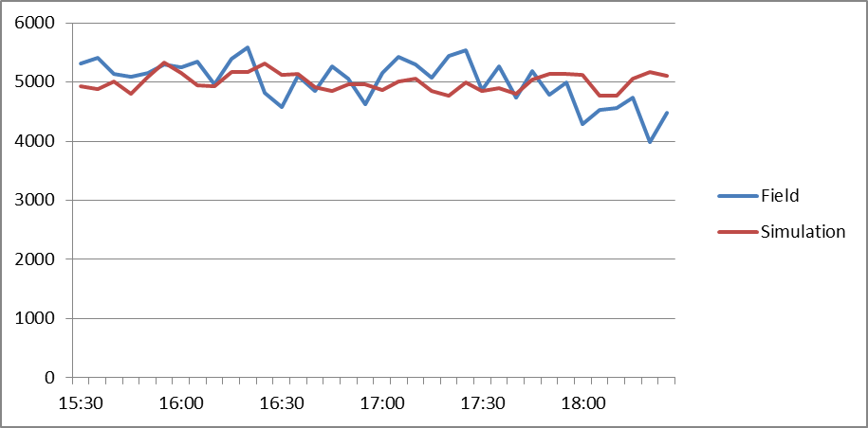

Interchange #4

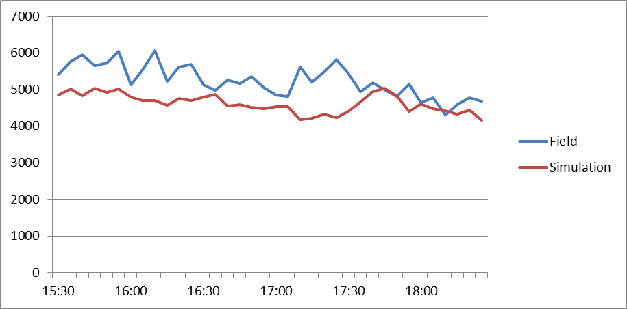

Interchange #5

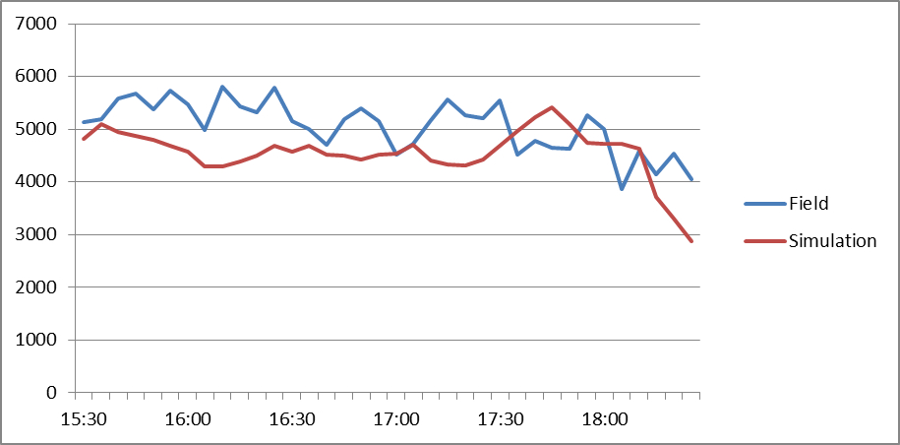

Interchange #6

1. **Calibration Results : Speed-Flow Curve**

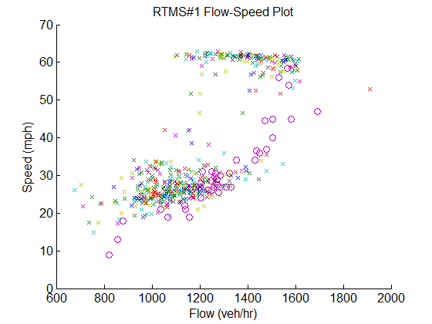

Interchange #1 (Circle: Field; x-mark: Simulation)

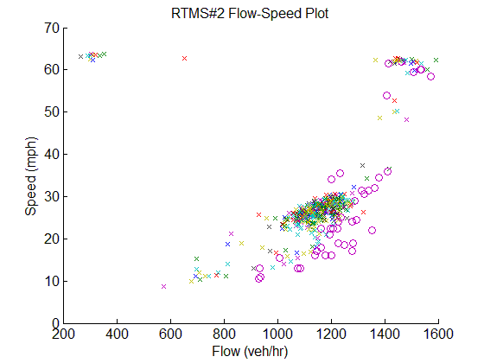

Interchange #2(Circle: Field; x-mark: Simulation)

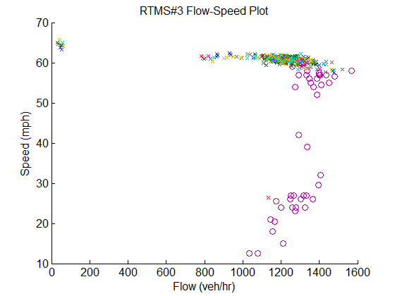

Interchange #3(Circle: Field; x-mark: Simulation)

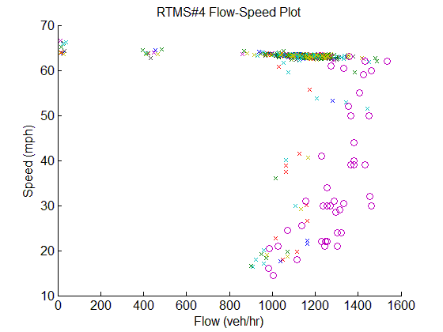

Interchange #4(Circle: Field; x-mark: Simulation)

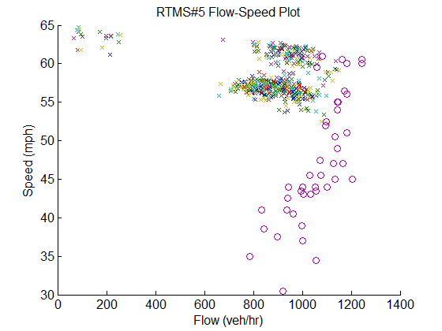

Interchange #5(Circle: Field; x-mark: Simulation)

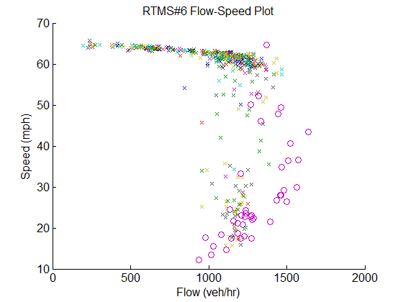

Interchange #6(Circle: Field; x-mark: Simulation)

1. **Speed/Flow-based Calibration Results**

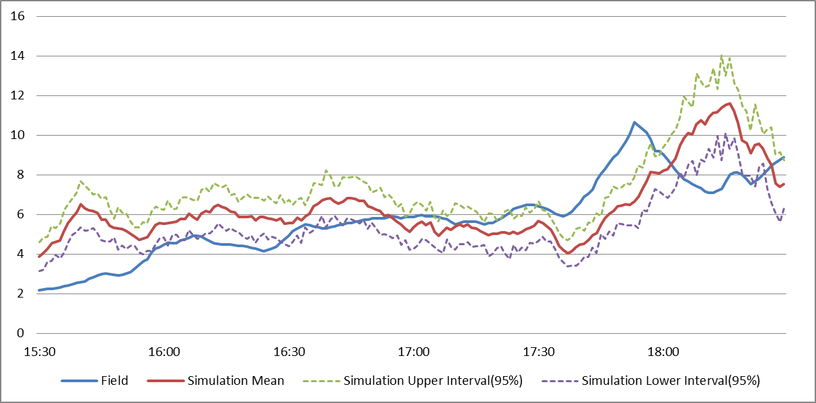

TMC 110+01476

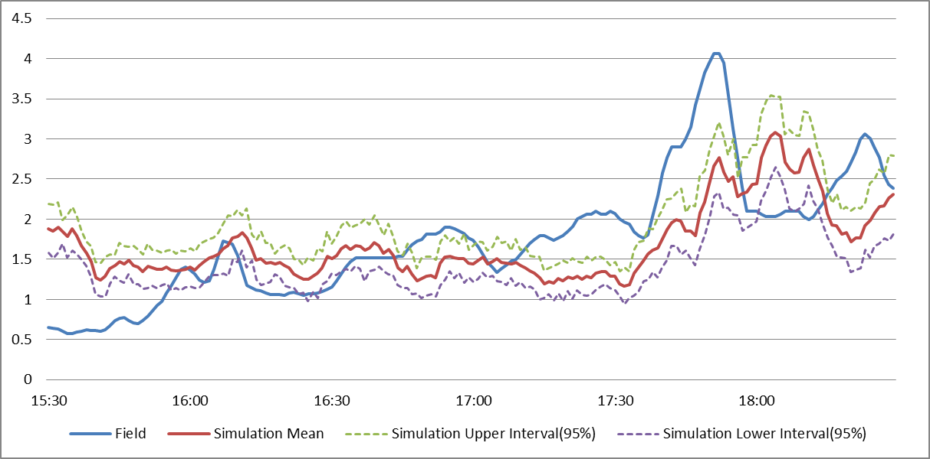

TMC 110P01476

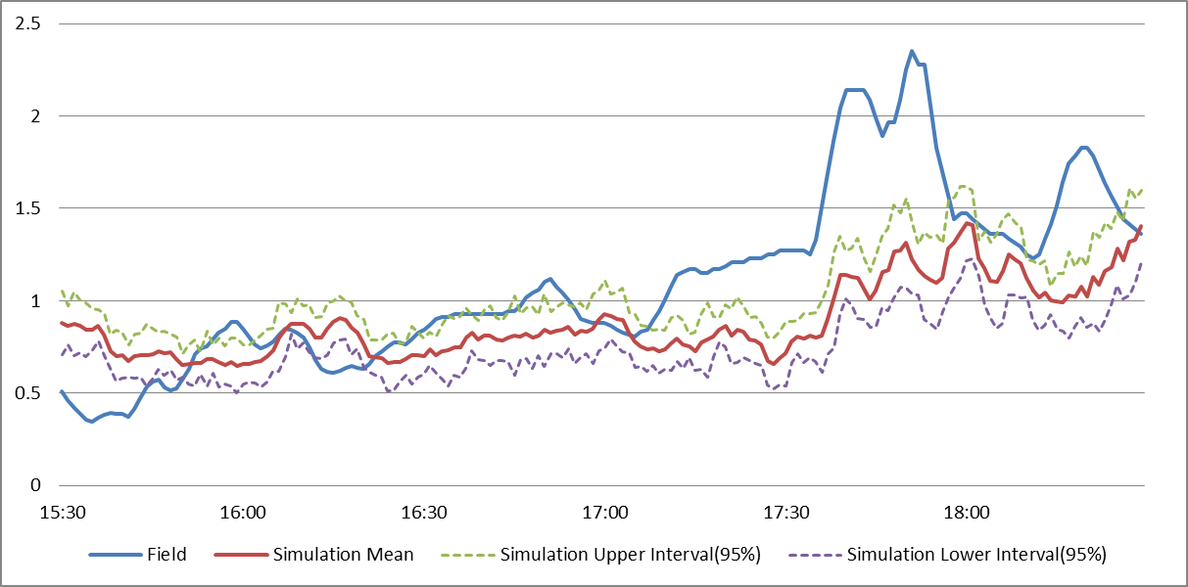

TMC 110+01477

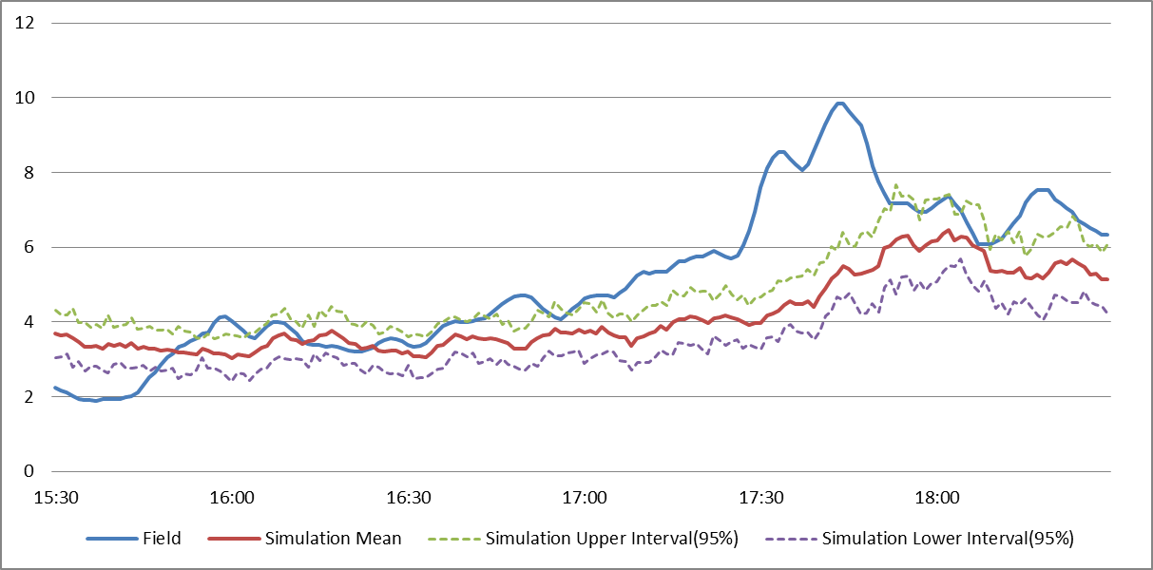

TMC 110+01478

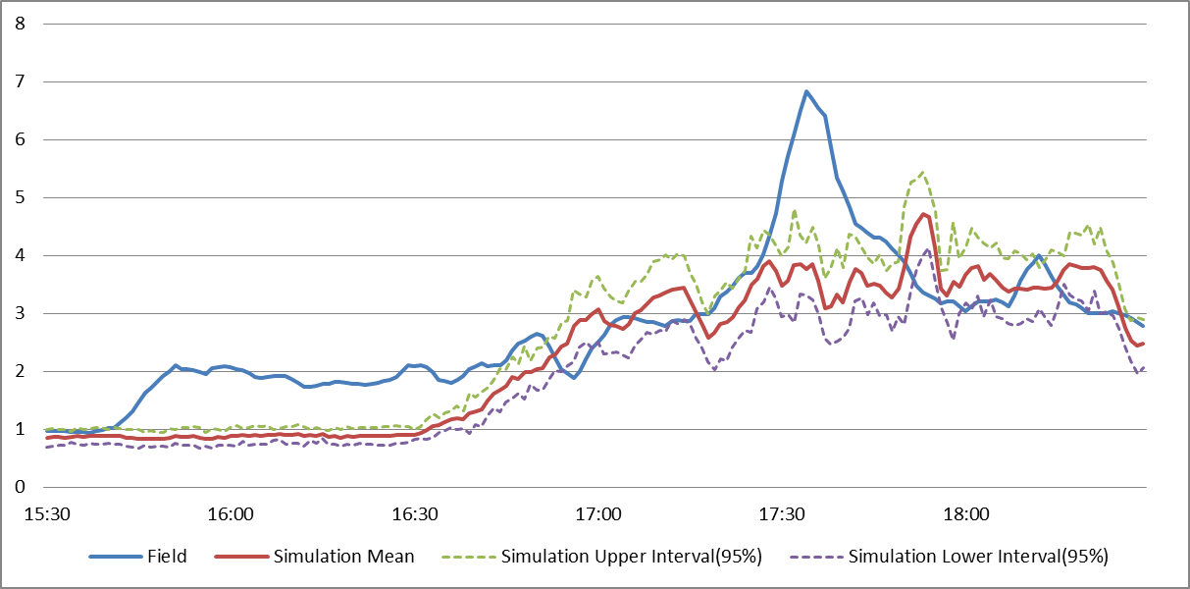TMC 110P01478